About Centre for grassroots research & innovation

**Grassroots Innovation** is about learning directly from communities — especially in villages — by observing how people creatively address everyday challenges with limited resources and immense wisdom.

As part of this initiative, students will visit nearby villages to **learn from the lived experiences of common people**, gain **life lessons**, and understand **local problems** that demand thoughtful solutions.

Through this process, students will not only **observe innovative practices emerging from the grassroots**, but also **apply their own critical and innovative thinking** to design solutions that bridge classroom knowledge with real-world needs.

This initiative offers a unique opportunity for students to connect **education with empathy**, **engineering with society**, and **innovation with purpose** — shaping a new generation of socially responsible thinkers and doers.

Honorary Chairs

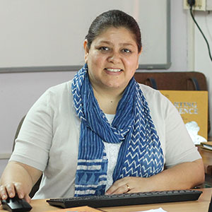

Prof. Anjula Gurtoo

Professor & Chair, Lab for Sustainable Solutions

Department of Management Studies, Indian Institute of Science, Bangalore

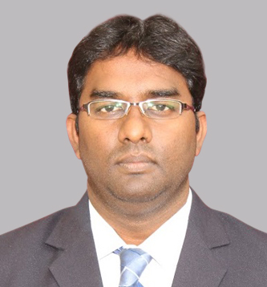

Dr. K. Elangovan

Assistant Innovation Director, Innovation Cell

Ministry of Education, New Delhi



Dr. Gurubalan Annadurai

Assistant Professor, Department of Energy Science and Engineering

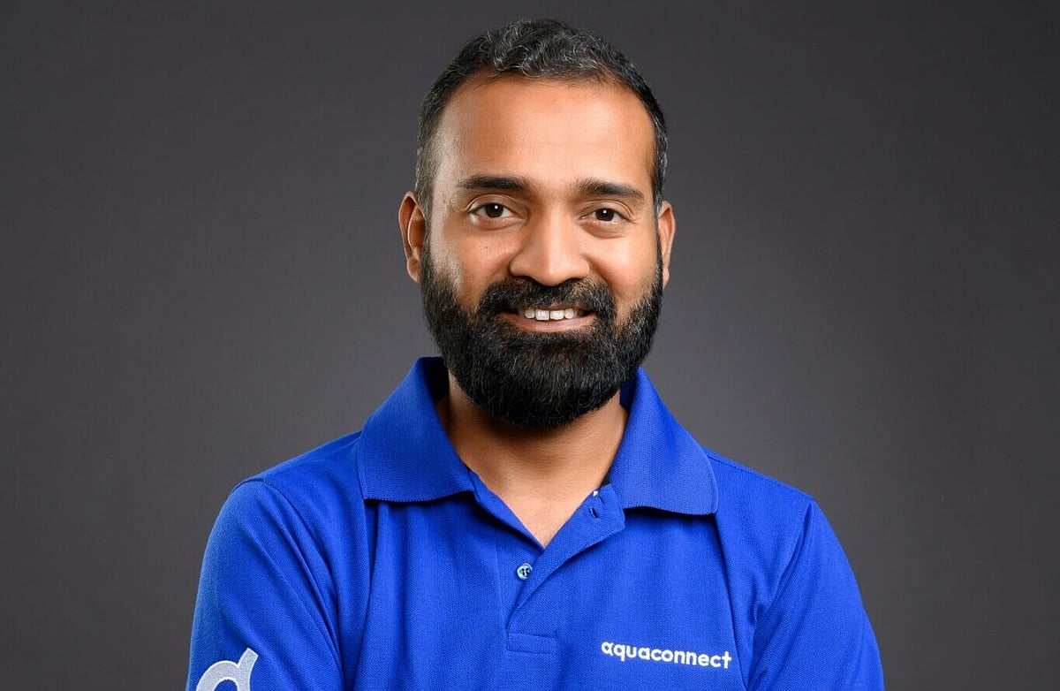

Mr. K. S. Rajamanokar

CEO, Aquaconnect, Chennai

Chair

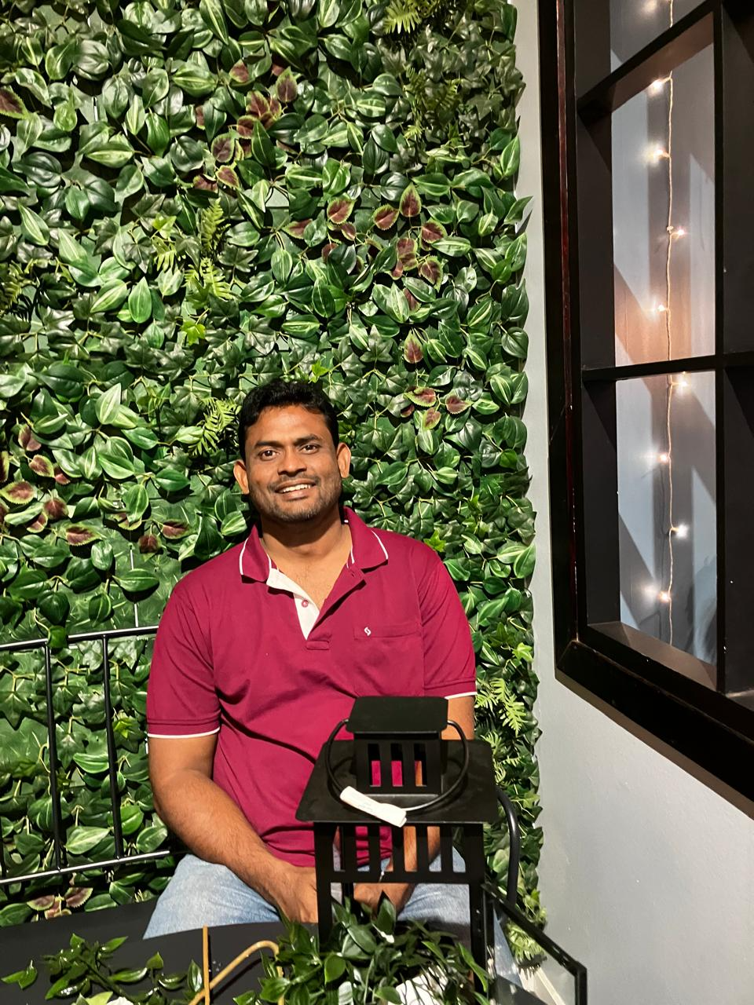

Dr. M. Arulprakasajothi

Director – Innovation, JAIN University

Co Chair

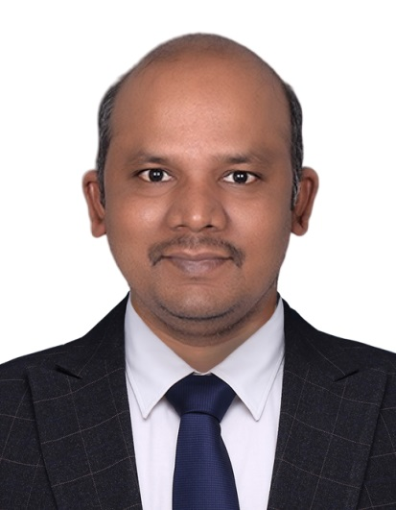

Dr. N. Beemkumar

Deputy Dean (Research), JAIN University

Faculty coordinators (Need to get photos from the faculty)

**Dr. M John Basha**

Assistant Professor

**Dr. Sowmya M S**

Assistant Professor

Dr. Vichitra M.

Assistant Professor

**Miss Agashini V Kumar**

Assistant Professor

**Mrs. Savitha R.**

Assistant Professor, EEE